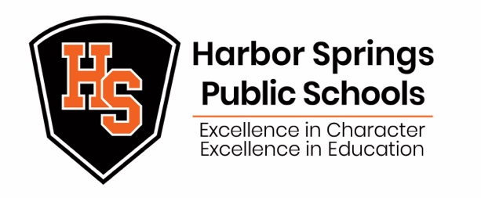

April 1, 2021

Dear Harbor Springs Public Schools Community:

RE: COVID Update

Late yesterday afternoon, the Health Department of Northwest Michigan contacted the District to inform us of two more positive COVID cases in our school community:
- Harbor Springs High School 10th Grade Student (exposure dates March 23, 24, and 25)
- Harbor Springs High School 12th Grade Student (exposure date March 25)

We have concluded contact tracing and have contacted all parents/guardians of students that may have been close contacts on the dates of exposure.

As we approach the completion of spring break, I strongly encourage our students and families to remain vigilant and practice COVID precautions by following the CDC, MDHHS, and the Health Department of Northwest Michigan. Our goal is, and always has been, to keep school open for face-to-face learning while balancing the health and safety of our students, staff, families, and community. For the most updated data, please visit the District’s COVID Website.

Sincerely,
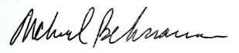
Michael Behrmann
Superintendent of Schools

