Hammerhead Swim Club -
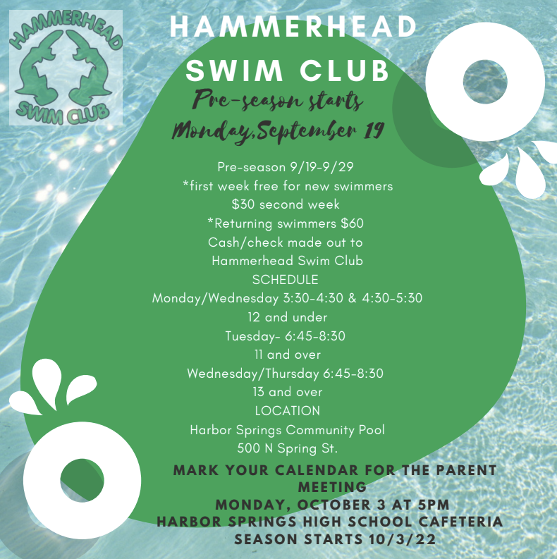
Upcoming Events
Friday, September 23
Festival of the Book Presentations (ELA classrooms) 3rd & 4th Hours
Monday, October 3
Hammerhead Swim Club Parent Meeting (HSHS Cafeteria) 5:00 pm
Saturday, October 8
Homecoming Dance (HSHS Cafeteria) 8:00 - 11:00 pm
Wednesday, October 12
PSAT/NMSQT (National Merit Scholarship Qualifying Test) - OPTIONAL Parent/Teacher Conferences 3:30 - 6:30 pm
Thursday, October 13
Michigan Youth in Government Fall Training Conference (Traverse City) Parent/Teacher Conferences 5:00 - 8:00 pm
Friday, October 14
NO SCHOOL - Teacher Professional Development

